A picture containing clipart

Description generated with very high confidence

NodeJS Module 6

Hands On - 1

[**support@intellipaat.com**](mailto:support@intellipaat.com)

**+91-7022374614**

**US: 1-800-216-8930(Toll Free)**

**NodeJS Module 6: Hands-on: 1**

**Install Express in a project**

**Step 1:** Open a command prompt in your project folder. 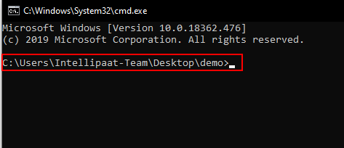

**Step 2:** Run the command npm init -y to create an npm project in your folder.

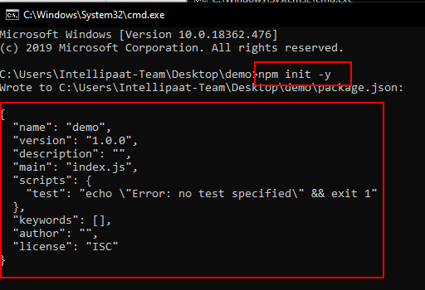

**Step 3:** Notice that package.json is created in your folder.

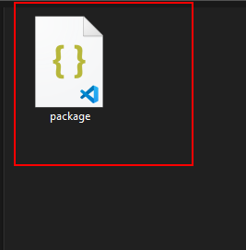

**Step 4:** Run the command npm install express.

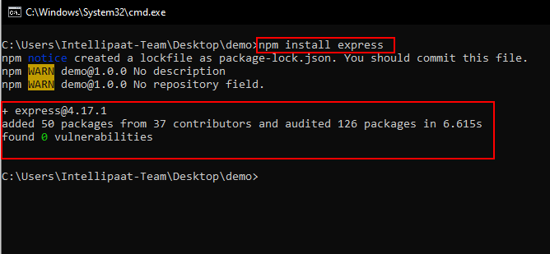

**Step 5:** After the command finishes look inside the newly created folder named node-modules.

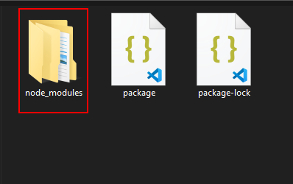

**Step 6:** Inside it you will see a folder named express which means it’s installed.

